# DIAGRAMS AND SRS

Table of Contents

DIAGRAMS AND SRS 1

PATIENT ERD 2

UNIFIED ERD 2

SCHEMA DIAGRAM (PATIENT MODULE) 3

FUNCTIONAL REQUIREMENTS 3

FR01: PATIENT REGISTRATION 3

FR02: PATIENT LOGIN 3

FR03: PERSONALIZED DASHBOARD 3

FR04: MEDICAL RECORDS MANAGEMENT 4

FR05: PATIENT PROFILE 4

FR06: PRESCRIPTIONS 4

FR07: APPOINTMENTS 4

FR08: PRESCRIPTION-APPOINTMENT ASSOCIATION 4

NON-FUNCTIONAL REQUIREMENTS 4

NFR01: SCALABILITY 4

NFR02: USABILITY 5

NFR03: MAINTAINABILITY 5

USE-CASE 5

WIREFRAME 6

DFD 7

LEVEL 0 7

LEVEL 1 7

TESTING 8

STATE TRANSITION TESTING 8

## PATIENT ERD

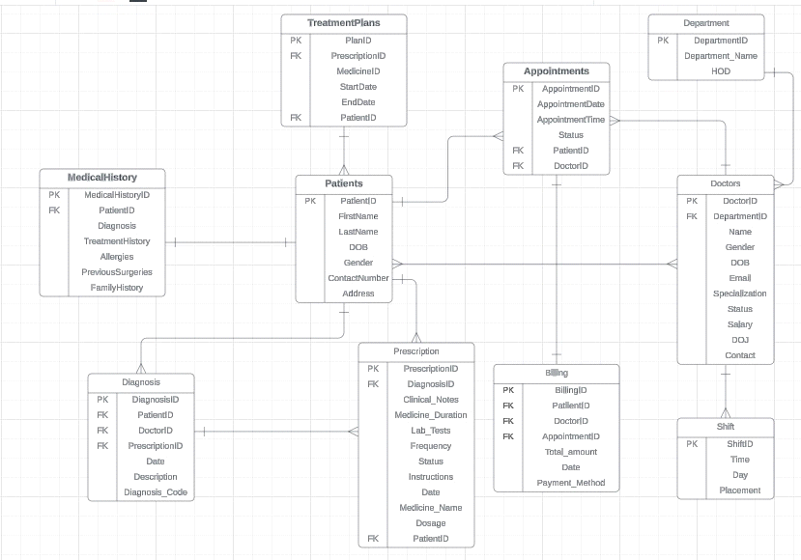

## UNIFIED ERD

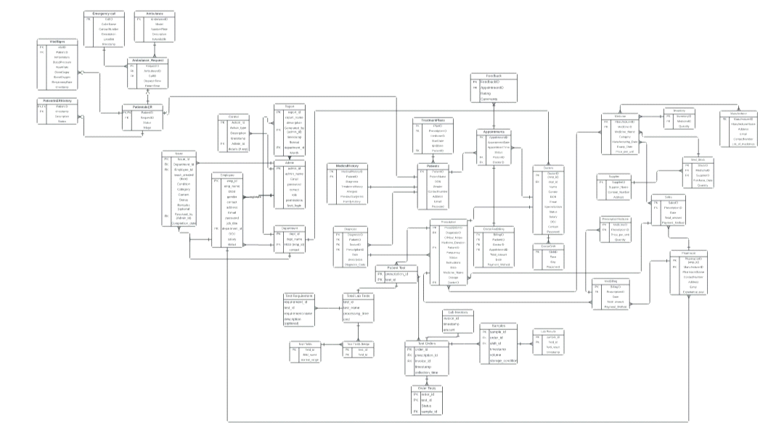

## SCHEMA DIAGRAM (PATIENT MODULE)

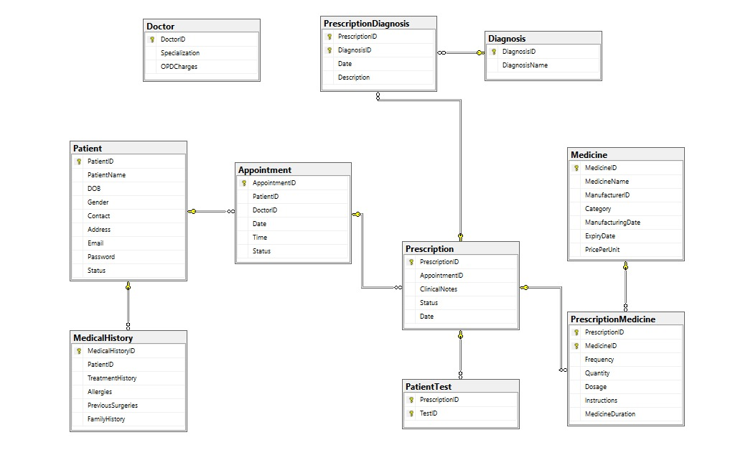

## FUNCTIONAL REQUIREMENTS

### FR01: PATIENT REGISTRATION

|  |  |
| --- | --- |
| **Req. No.** | **Functional Requirements** |
| FR01-01 | Allowing new patients to register by capturing vital information such as their name, contact information, address, date of birth, and gender. |
| FR01-02 | It should support the assignment of a unique patient identifier to each registered patient. |

### FR02: PATIENT LOGIN

|  |  |
| --- | --- |
| **Req. No.** | **Functional Requirements** |
| FR02-01 | The system must include a secure login method for registered patients to access their personal health information. |
| FR02-02 | Patients must provide unique email and password credentials for authentication. |

### FR03: PERSONALIZED DASHBOARD

|  |  |
| --- | --- |
| **Req. No.** | **Functional Requirements** |
| FR03-01 | Upon login, patients shall be directed to a personalized dashboard displaying relevant information, such as appointments, recent diagnosis, and ongoing treatment plans. |

### FR04: MEDICAL RECORDS MANAGEMENT

|  |  |
| --- | --- |
| **Req. No.** | **Functional Requirements** |
| FR04-01 | The system should facilitate the creation, storage, and retrieval of medical records for each patient. |
| FR04-02 | It should support the recording of patients' medical history, allergies, medications, treatment plans and other relevant clinical data. |

### FR05: PATIENT PROFILE

|  |  |
| --- | --- |
| **Req. No.** | **Functional Requirements** |
| FR05-01 | Allow patients to view and update their personal details, including name, gender, date of birth, address, and contact information. |
| FR05-02 | Display a comprehensive overview of the patient's medical history, including past diagnoses, surgeries, and chronic conditions. |

### FR06: PRESCRIPTIONS

|  |  |
| --- | --- |
| **Req. No.** | **Functional Requirements** |
| FR06-01 | Allow patients to view active prescriptions and review prescription history.  Display detailed information about prescribed medications, including name and category, and dosage instructions. |

### FR07: APPOINTMENTS

|  |  |
| --- | --- |
| **Req. No.** | **Functional Requirements** |
| FR07-01 | Display a list of upcoming and past appointments, including date, time and doctor.  Allow patients to access specific details for each appointment, including the doctor's name, specialty, and contact information. |

### FR08: PRESCRIPTION-APPOINTMENT ASSOCIATION

|  |  |
| --- | --- |
| **Req. No.** | **Functional Requirements** |
| FR08-01 | Allow patients to access a list of prescriptions linked to specific appointments within their profile. |
| FR08-02 | Provide a clear indication next to each prescription of the associated appointment for which it was prescribed. |

## NON-FUNCTIONAL REQUIREMENTS

### NFR01: SCALABILITY

|  |  |
| --- | --- |
| **Req. No.** | **Non Functional Requirements** |
| NFR03-01 | The system needs to be built with scalability in mind to handle future increases in the quantity of data, users, and patients. |
| NFR03-02 | It should allow for the addition of further resources without affecting performance or reliability. |

### NFR02: USABILITY

|  |  |
| --- | --- |
| **Req. No.** | **Non Functional Requirements** |
| NFR05-01 | The user interface should be intuitive, user-friendly, and accessible to users with varying levels of technical knowledge. |

### NFR03: MAINTAINABILITY

|  |  |
| --- | --- |
| **Req. No.** | **Non Functional Requirements** |
| NFR06-01 | The system should be flexible, well-documented, and easy to maintain and upgrade.  It should adhere to coding standards and best practices to facilitate code reuse, debugging, and troubleshooting. |

## USE-CASE

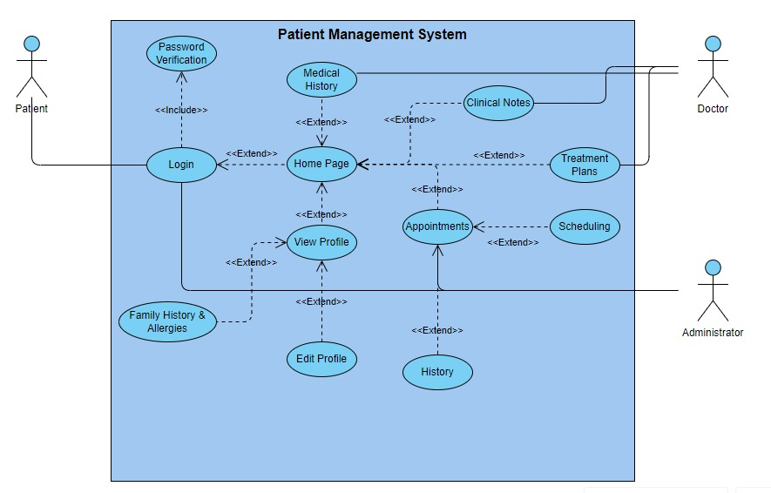

## WIREFRAME

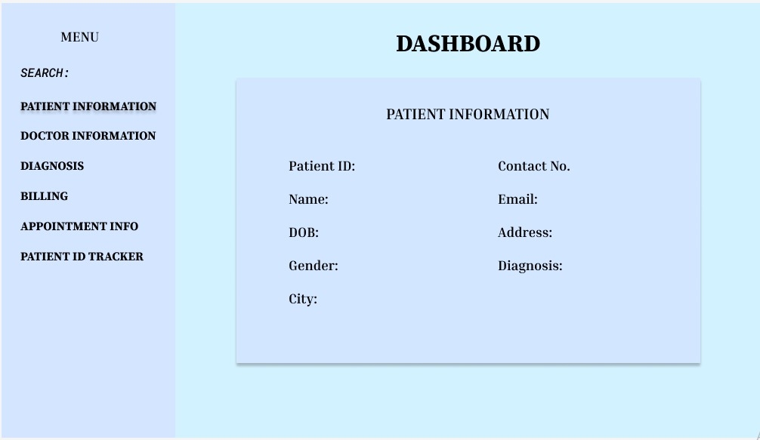

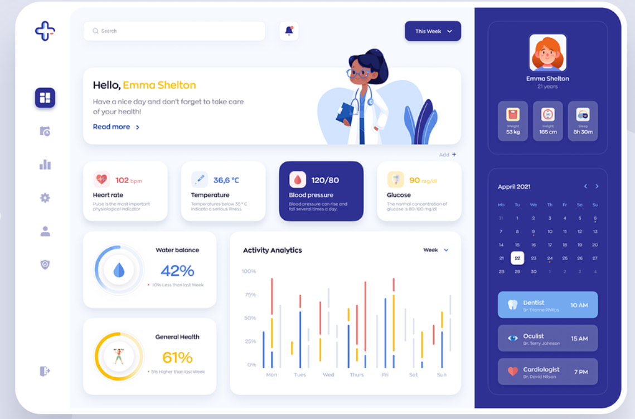

## DFD

### LEVEL 0

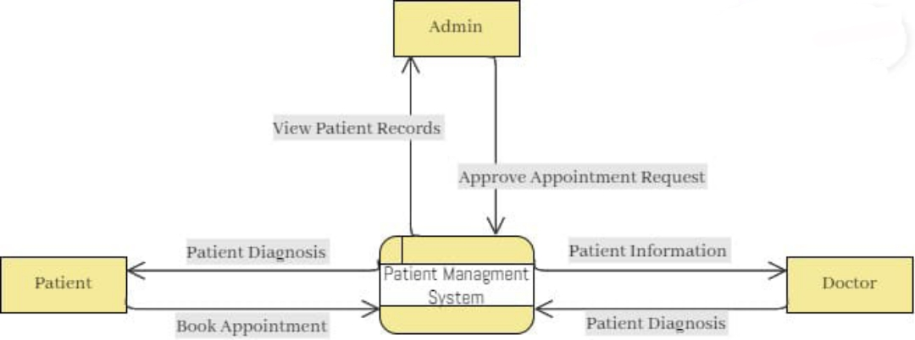

### LEVEL 1

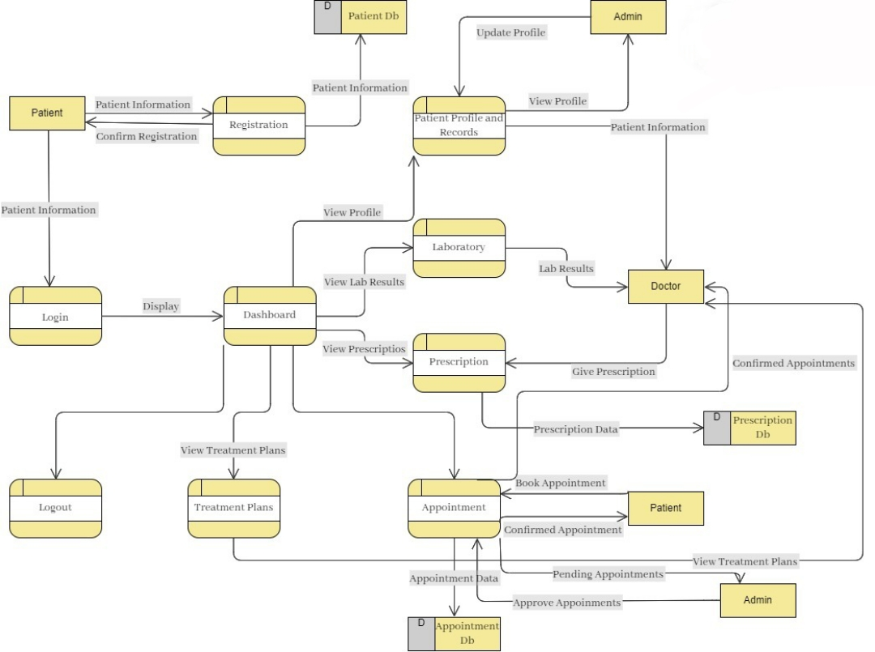

## TESTING

### STATE TRANSITION TESTING

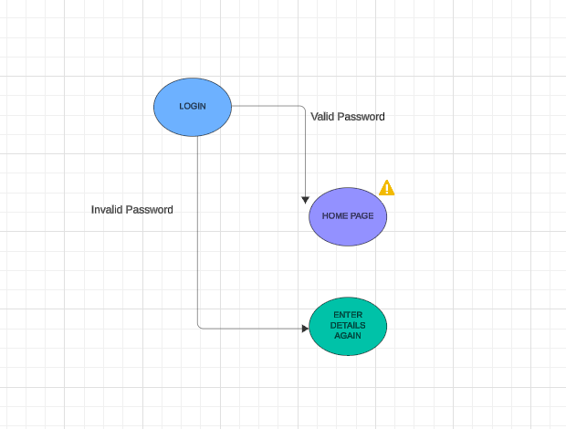

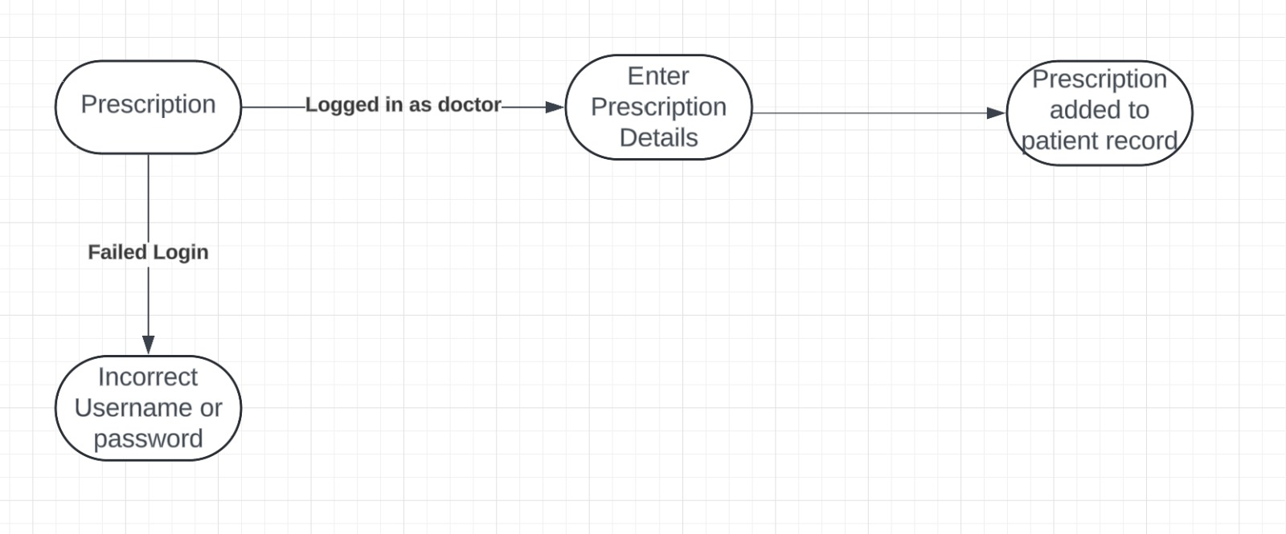

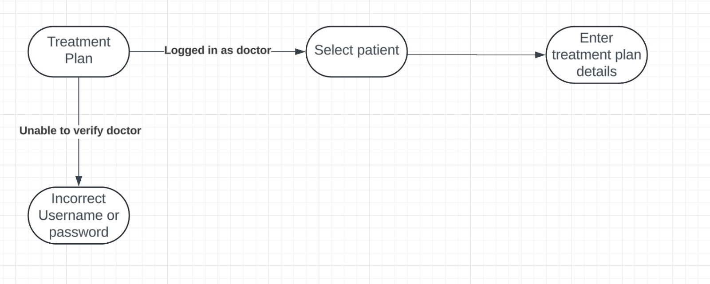

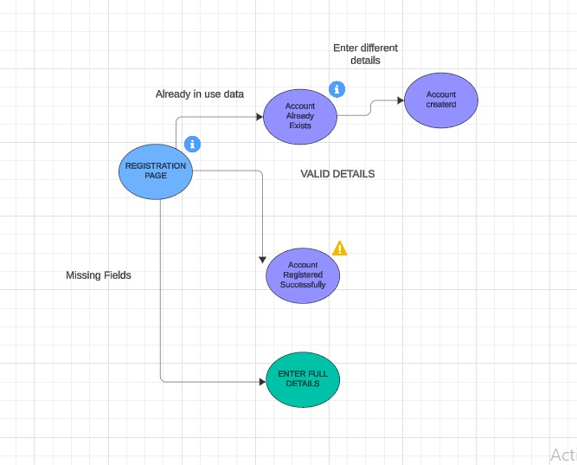

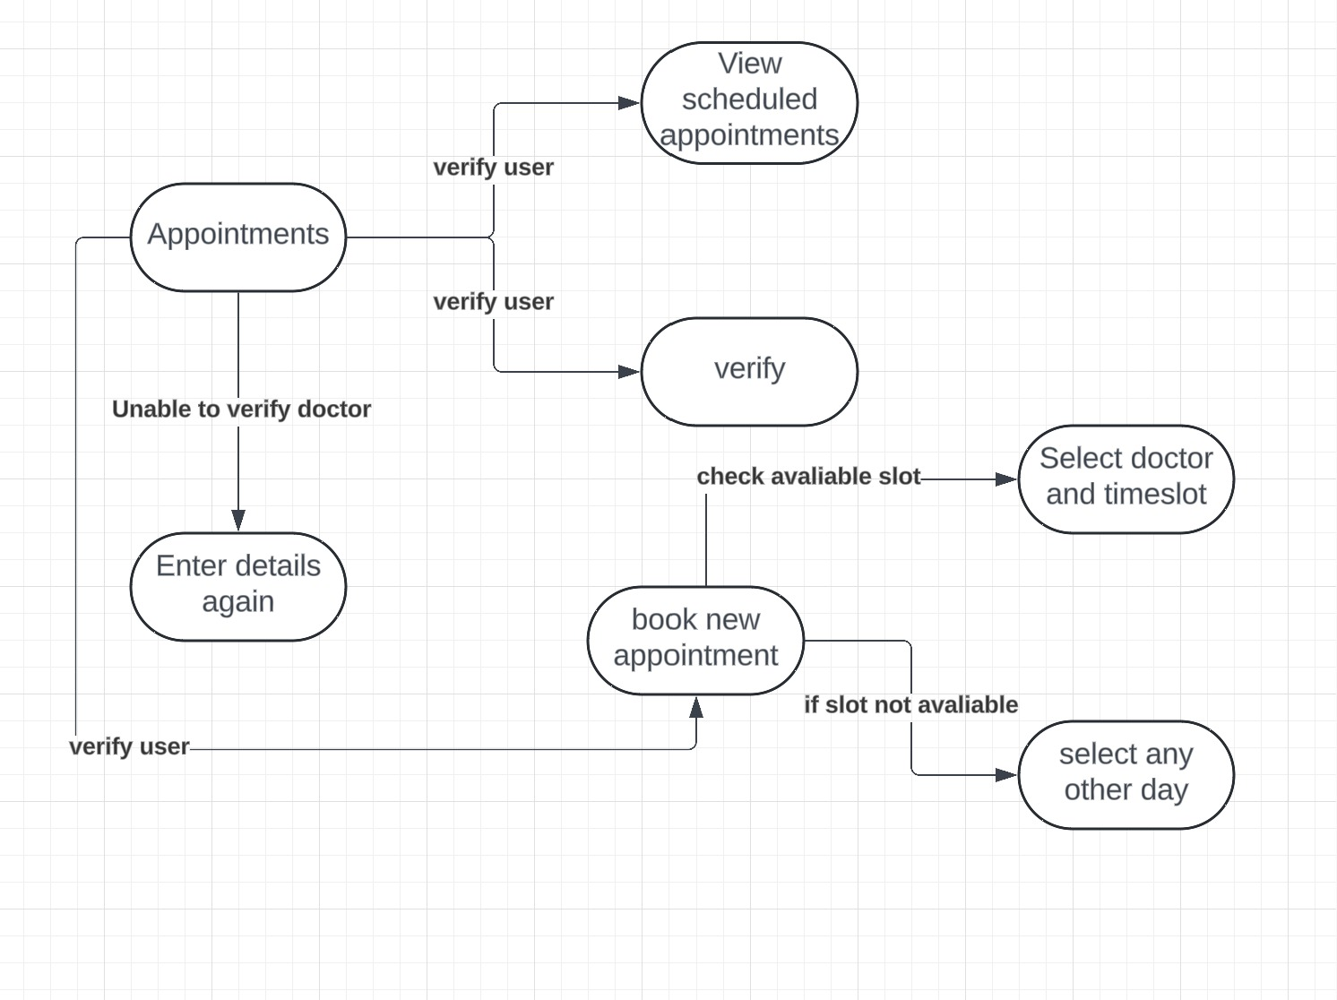

## TOOLS

1. Figma <https://www.figma.com/>
2. LucidChart <https://www.lucidchart.com/pages/>